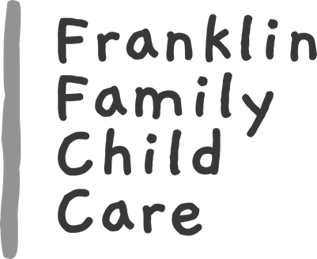 Questionnaire

Date______________________

Child’s Name __________________________________________________
Nickname/Preferred Name _______________________________________
Child’s age_______________________________
Child’s Birthday________________________
Are you concerned that your child may be prone to any type of allergies?___________
Describe: ____________________________________________________________________________________________________________________________________________
______________________________________________________________________
Does your child have any medical conditions which I should be made aware of? ____________________________________________________________________________________________________________________________________________
______________________________________________________________________
Has your child had the following common childhood illnesses?
.(please circle)
Does your child have any problems with any of these? | Has your child had any of these diseases?
Constipation | Asthma
Convulsions | Bronchitis
Diarrhea | Chicken Pox
Fainting Spells | Diabetes
Frequent Colds | Heart Disease
Frequent Ear Infections | Hepatitis
Frequent Sore Throats | Impetigo
Lice | Measles
Ringworm | Mumps
Skin Rash | German Measles
Soiling | Polio
Stomach Upsets | Scarlet Fever
Urinary Problem | Tuberculosis
Worms | Whooping Cough

Does your child have any speech, hearing or visual problems? ____________________________________________________________________________________________________________________________________________
Would there be any restrictions to play or activities? ______________________________________________________________________
______________________________________________________________________

About Your Child

Has your child ever been in childcare before? ______________________________
What type (center, family daycare, grandma etc.). _____________________________
Was it a positive experience? ______________________________________________
Why are you looking for childcare? _________________________________________________________________________________________________________________________________
How does your child feel about daycare and being cared for by someone other than his/her parent(s)? ____________________________________________________________________________________________________________________________________________
Are there any recent traumatic situations the child has been exposed to such as a death in the family, divorce, new sibling etc. that you wish to share about? ____________________________________________________________________________________________________________________________________________
What is your normal method of discipline? ____________________________________________________________________________________________________________________________________________

What is your child's temperament? Are they easy going, hard to please, demanding, aggressive, etc. ______________________________________________________________________
______________________________________________________________________
Are there any food restrictions? ____________________________________________________________________________________________________________________________________________
What are your child's favorite foods? _____________________________________________________________________
______________________________________________________________________
What foods does your child dislike? ______________________________________________________________________
______________________________________________________________________

Can your child be relied upon to indicate bathroom wishes? ______________________________________________________________________
_____________________________________________________________________
What words does your child use for:
Bowel movements _________________ urination__________________
What time does your child awaken? ___________________________________________
What time does your child go to sleep at night? __________________________________
Do they sleep through the night? _____________________________________________
Does your child sleep in a bed or crib, other? ____________________________________
Are there any siblings? Please name them and specify ages and gender.
Name _____________________ age __________________ gender _______________
Name ______________________ age __________________ gender ______________
Name ______________________ age __________________ gender ______________
Has your child had experience playing with other children? ______________________________________________________________________
______________________________________________________________________
What language(s) are spoken at home? ______________________________________________________________________
Does your child have any security objects such as a blanket, soother, bottle, toy etc. ? ______________________________________________________________________
______________________________________________________________________
What are your child's favorite activities, toys, books, or games? ____________________________________________________________________________________________________________________________________________

Are there any other comments or information you would like to let me know about? ______________________________________________________________________
__________________________________________________________________________________________________________________________________________________________________________________________________________________

Any specific concerns?___________________________________________________________________________________________________________________________________
____________________________________________________________________________________________________________________________________________

